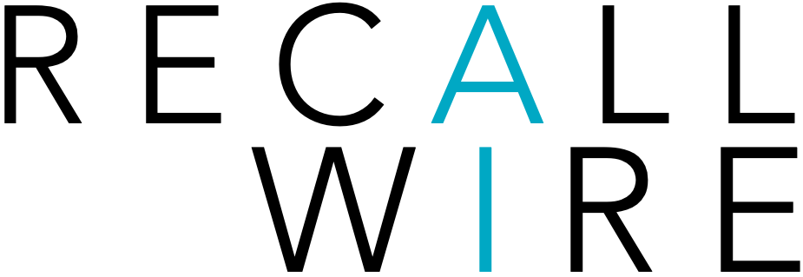

Job Title: Commission-Only SaaS Sales Representative

Location: Remote

Compensation: 100% Commission-Based (Uncapped Earnings)

Employment Type: Independent Contractor / 1099

About the Role
You will be responsible for identifying prospects, managing the sales cycle, and closing new business for our SaaS product. This role offers flexibility, autonomy, and high upside.

Responsibilities
- Prospect and generate new leads via outbound outreach, networking, and inbound follow-up
- Schedule and conduct product demos and discovery calls
- Understand customer pain points and position our SaaS solution effectively
- Manage the full sales cycle from lead to close
- Maintain accurate pipeline and activity tracking in CRM
- Meet or exceed monthly and quarterly sales targets
- Collaborate with leadership on lead feedback and messaging
- Represent the company professionally and ethically at all times

Compensation Structure
- 100% commission-based (no cap)
- Competitive commission percentage per sale
- Recurring commission available (if applicable)
- Performance-based bonuses and accelerators
- Opportunity to transition into a salaried role based on performance

Success Metrics
- Deals closed per month
- Revenue generated
- Conversion rate from lead to close
- Pipeline activity and follow-up consistency

